Capstone Project Document

DSIA – Data Science and AI Course
Part-time – 2019-12-10

Luiz Augusto FERREIRA CARNEIRO

Process overview
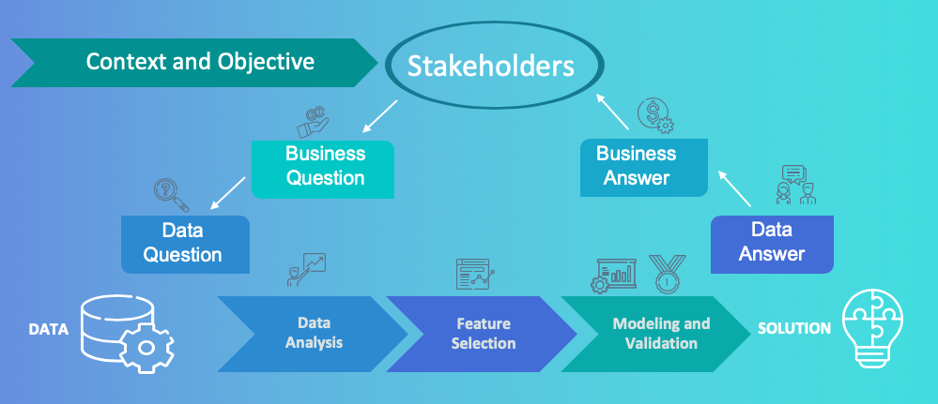

Problem statement
- What is the problem or the opportunity that the project is investigating?

To predict the length of stay of admitted patients at the time of admission to a hospital.

- Why is this problem valuable to address?

Because “extended lengths of stay are a drain on hospital resources, personnel and the bottom line, costing hospitals millions of dollars a year.”

- What is the current state (e.g. unsatisfied customers, lost revenue)?

Health expenditure has been rising above inflation in Australia.
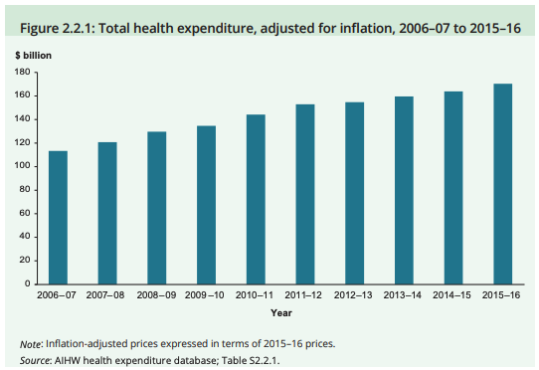

The estimated annual expenditure with CVD hospitalisations in Australia is
$8.14 billion (improving efficiency by 1% means saving $81.4 million).

- What is the desired state?

More efficiency, and better quality of health care.

- Has this problem been addressed by other research projects? What were the outcomes?

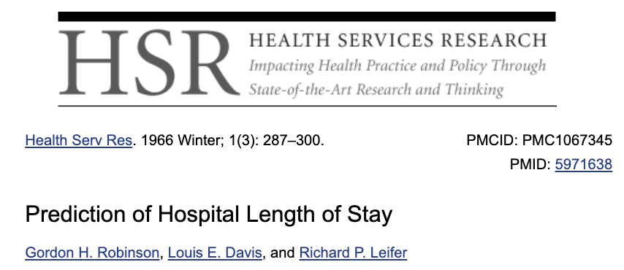
Yes. Many studies in the last few decades have approached this problem. For
example:


Industry/ domain
- What is the industry/ domain?

Healthcare.

- What is the current state of this industry? (e.g. challenges from startups)

Rising costs, inefficiency and waste.

- What is the overall industry value-chain?

Suppliers > Healthcare Providers > Patients (payers)

- What are the key concepts in the industry?

The objective of this industry is to achieve the “Triple Aim”: improve quality, reduce costs and maximise the patient’s experience.

- Is the project relevant to other industries?

Yes, to the health insurance industry, for example.

Stakeholders
- Who are the stakeholders? (be as specific as possible)

Patients, healthcare provides, suppliers (pharmaceutical companies, medical device companies, hospital equipment companies), payers (patients, government and health insurers).

- Why do they care about this problem?

Excess length of stay has an impact on the cost of hospitalisations because of the excessive use of resources.

- What are the stakeholders’ expectations?

Some stakeholders in the healthcare sector have conflicting interests. However, the most important stakeholder is the patient, which expects the get the right care at the right time.

Business question
- What is the main business question that needs to be answered?
How can we predict LOS so hospitals are able to identify patients who might be at risk for an extended stay, and subsequently alter a patient's treatment plan from the point of admission to reduce the hospital stay? In this project, the focus is on cardiovascular-disease (CVD) hospitalisations.

- What is the business value of answering this question? (quantify value and make necessary assumptions)

The estimated annual expenditure with CVD hospitalisations in Australia is
$8.14 billion (improving efficiency by 1% means saving $81.4 million).

- What is the required accuracy? What are the implications of false positives or false negatives?

This question does not apply to this study. This is not a classification problem.

Data question
- What is the data question that needs to be answered?

Which patient’s characteristics at admission at the hospital better explain the LOS?

- What is the data required to answer the question?

Length of stay and patient’s “intrinsic health risk” characteristics.

Data
- Where was the data sourced?

The data was provided by DRG Brasil ® (www.drgbrasil.com.br)

- What is the volume and attributes of the data?

19,431 CVD hospitalizations. 356 features.

- How reliable is the data?

Extremely reliable.

- What is the quality of the raw data?

Very good.
- How was this data generated?

DRG Brasil ® generate the data from hospitalisations from many hospitals in Brazil.

- Is this data available on an ongoing basis?

Yes. But it is a private data set.

Data science process

Data analysis
- What data pipeline was to wrangle the raw data?

The data was provided by DRG Brasil ®.

- What are the highlights of the Exploratory Data Analysis (EDA)?

Length of stay varies a lot:
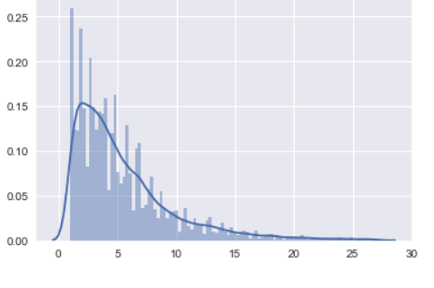
Number of Days at Hospital

- Is the pipeline reusable? (for example, to process future data?)

Yes. Totally.

- What are the intermediary data structures used (if any)?

Modelling
- What are the main features used?

Using Random Forest, 30 features were selected among a total of 356 features.

- Is there a subset of features that would get a significant portion of your final performance? Which features?

Age at admission; ischemic heart disease; flu/pneumonia; renal insufficiency; other CVDs.

- How did you select features?

Random forest.

- What are the models used?

Decision tree regressor to generate decision trees, for visualisation and useful insights.

MLP Regressor, Linear Regressor and Gradient Boosting Regressor.

- How long does it take to train your model?

A few minutes, with this data set.

- What are the tools used? (cloud platform, for example)

Google Colab, with GPU.

- What are the model performance metrics?

MSE

- Which model was selected?

Gradient Boosting Regressor

Outcomes
- What are the main findings and conclusions of the data science process?

Some features not directly related to CVD, like flu/pneumonia and renal insufficiency, can also have a significant impact on the length of stay of CVD patients.

It is possible to identify the combination of features that cause different length of stay among patients.

With the right data, this data science process is replicable for all types of hospitalisations.

Implementation
- What are the considerations for implementing the model in production?

The predicted length of stay can be easily incorporated in existing platforms in hospitals.

Data answer
- Was the data question answered satisfactorily?

Yes. The relevant features were identified.

- What is the confidence level in the data answer?

R square in the random forest model was above 70% (for feature selection). R square in the regression models was above 80% and MSE for the Gradient Boosting Regressor was the lowest.

Business answer
- Was the business question answered satisfactorily?

Yes. The length of stay can be better managed by using the relevant patient’s characteristics.

- What is the confidence level in the business answer?

Same as above.

Response to stakeholders
- What are the overall message and recommendations to the stakeholders?

The right health care to the right patient can be provided in hospital, based on patient’s characteristics.

End-to-end solution
- What is the overall end-to-end solution to use the model developed in the project?

References
- Where are the data and code used in the project? (show a simplified list of main items: notebooks, datasets, exported models)

Available at: github.com/lacarneiro

- What are the resources used in the project? (libraries, algorithms, etc)

Available at: github.com/lacarneiro

Source: https://go.beckershospitalreview.com/how-predicting-patient-length-of-stay-enables-hospitals-to-save-millions

